AtomicLearning.com

reviewed by Shannon McCue

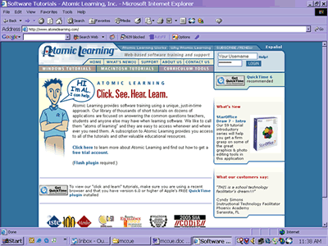
Atomiclearning.com is a website that provides software training for various Windows and Macintosh applications. Some of the application tutorials for Mac are Dreamweaver, Photoshop, excel, illustrator, Final Cut Pro, GarageBand. Windows tutorials include Acrobat reader, Flash MX 2004, Word, and PowerPoint. The list goes on and on. There are thousands of short tutorials on dozens of applications, focused on answering the common questions that teachers, students and other users might have when learning software programs.
What I like most about this website is its ability to breakup the learning process into the basic need to know essentials. It sets you up with five or six 2- to 3- minute QuickTime tutorials and takes you through the process of setting up and starting a project. The only downside is if you want to get the full tutorial you have to sign up for a membership. But in my opinion it is well worth the money especially if you are working at a school, university, or ctc, and there is plenty of useful training available for free. These tutorials will be a tremendous help in providing training for staff, students and faculty. They also provide you with lesson plans, curriculum tools and workshop guides. This website is a very good resource for anyone working in the community technology field; I know I definitely will be using their tutorials more in the future.
________________________________________________________________________


Shannon McCue is a CTC VISTA working with the Community Media and Technology program at UMass Boston.

